7.3.9 Editors - 3D View - Sidebar - Tool Tab - Mesh - Weight Paint Mode
Detailed table of content 1
Tools tab in Weight Paint Mode 4
Weight painting at characters 4
Weight painting a plain mesh 6
Weight painting in combination with particles 7
Brushes Panel 7
Browse Brush 7
Custom Icon 8
Brush Settings Panel 8
Brush Settings Panel - Advanced Sub panel 10
Brush Settings Panel - Stroke Sub panel 10
Stroke Panel with Stroke method Space 10
Stroke Panel with Stroke method Curve 11
Stroke Panel with Stroke method Line 13
Stroke Panel with Stroke method Airbrush 14
Stroke Panel with Stroke method Dots 15
Brush Settings Panel - Falloff Sub panel 16
Selecting Points 16
Adding Points 16
Navigation elements 16
Brush Settings Panel - Cursor Sub panel 18
Cursor Checkbox 18
Cursor Color 18
Falloff Opacity 18
Texture Opacity 18
Symmetry Panel 19
Mirror 19
Radial 19
Options Panel 19
Auto Normalize 19
Multi Paint 19
Restrict 19
X Mirror 19
Topology Mirror 19

Detailed table of content
Detailed table of content
Detailed table of content 1
Tools tab in Weight Paint Mode 4
Weight painting at characters 4
Skinning 4
Enter and leave Weight painting 6
Switch bones 6
Weight painting a plain mesh 6
Weight painting in combination with particles 7
Brushes Panel 7
Browse Brush 7
Custom Icon 8
Brush Settings Panel 8
Blend 9
Weight 9
Size Pressure 9
Radius 9
Size Pressure 9
Use Unified Radius 9
Strength 9
Size Pressure 9
Use Unified Radius 9
Brush Settings Panel - Advanced Sub panel 10
Accumulate 10
Front Faces Only 10
Brush Settings Panel - Stroke Sub panel 10
Stroke Panel with Stroke method Space 10
Spacing Edit Box 10
Spacing Pressure 10
Dash Ratio 10
Dash Length 11
Jitter Edit Box 11
Jitter Pressure 11
Jitter Unit 11
Input Samples Edit Box 11
Stabilize Stroke 11
Smooth Stroke Radius Edit Box 11
Smooth Stroke Factor Edit Box 11
Stroke Panel with Stroke method Curve 11
Spacing Edit Box 12
Paint Curve edit box 12
Draw Curve Button 13
Jitter Edit Box 13
Jitter Pressure 13
Jitter Unit 13
Input Samples Edit Box 13
Stroke Panel with Stroke method Line 13
Spacing Edit Box 13
Jitter Edit Box 14
Jitter Pressure 14
Jitter Unit 14
Input Samples Edit Box 14
Stroke Panel with Stroke method Airbrush 14
Rate Edit Box 14
Jitter Edit Box 14
Jitter Pressure 14
Jitter Unit 14
Input Samples Edit Box 15
Smooth Stroke 15
Smooth Stroke Radius Edit Box 15
Smooth Stroke Factor Edit Box 15
Stroke Panel with Stroke method Dots 15
Jitter Edit Box 15
Jitter Pressure 15
Jitter Unit 15
Input Samples Edit Box 15
Stabilize Stroke 16
Smooth Stroke Radius Edit Box 16
Smooth Stroke Factor Edit Box 16
Brush Settings Panel - Falloff Sub panel 16
Selecting Points 16
Adding Points 16
Navigation elements 16
Zoom in and out 17
Tools 17
Reset View 17
Vector Handle 17
Auto Handle 17
Auto Clamped Handle 17
Reset Curve 17
Use Clipping 17
Delete Points 17
Curve Presets 17
Falloff Shape 17
Front face Falloff 17
Angle 18
Brush Settings Panel - Cursor Sub panel 18
Cursor Checkbox 18
Cursor Color 18
Falloff Opacity 18
Override Overlay 18
Use Cursor Overlay 18
Texture Opacity 18
Override Overlay 18
Use Cursor Overlay 18
Symmetry Panel 19
Mirror 19
Radial 19
Options Panel 19
Auto Normalize 19
Multi Paint 19
Restrict 19
X Mirror 19
Topology Mirror 19

Tools tab in Weight Paint Mode

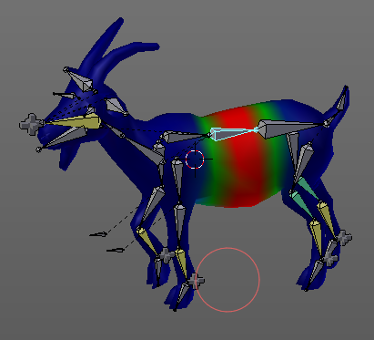
The Tools tab in Weight Paint Mode provides you the tools to do weight painting at a mesh. Skinned characters for example.
The vertices becomes a "weighting" assigned in this process. Means a per centage influence of the bone to a vertice. And under the hood you create vertex groups with the vertices that are assigned to the bones.
The amount of influence is defined by the weight paint color. Pure red has an influence value of 1. Pure blue has an influence value of 0. And the gradients between red and blue defines the in between steps in the 0-1 range. This is needed since there can be more than one bone influence and deform a vertice. Usually at the transition areas between two bones. The green areas in this shot.
The Weight Paint mode is just available for mesh objects.

Weight painting at characters
The main purpose for Weight painting is to weight the skin for characters. So that they deform proper when you pose your armature.

Skinning
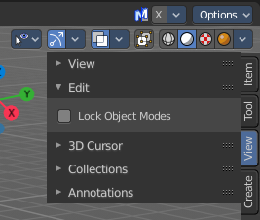
To do weight painting at a character you first have to assign the mesh to the armature. This process is called skinning. The mesh becomes the "skin" for the skeleton.
Let's do a quick run through skinning. You can skin in Object Mode. But also from Pose Mode. Lock Object Modes needs to be unticked to get it to work from Pose Mode, which it is by default. In case you have it on, untick it now.

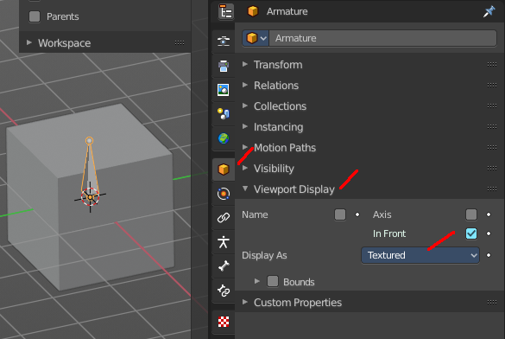
Create an object, create an armature
First we activate Display "in Front" for the armature. So that we can still see the armature inside of the mesh.
Position the mesh at its final location.
Now select the Mesh, hold down Shift key, and select the Armature. Both should be selected now.
Dive into the Object menu in the header of the 3D view, and search for Parent, with automatic weights. You can also press the hotkey Ctrl P. This calls the parenting menu under the mouse position.
Here we choose "With Automatic Weights". Automatic weighting means that the bones grabs the nearest vertices within a given radius, and assigns them to this bone.
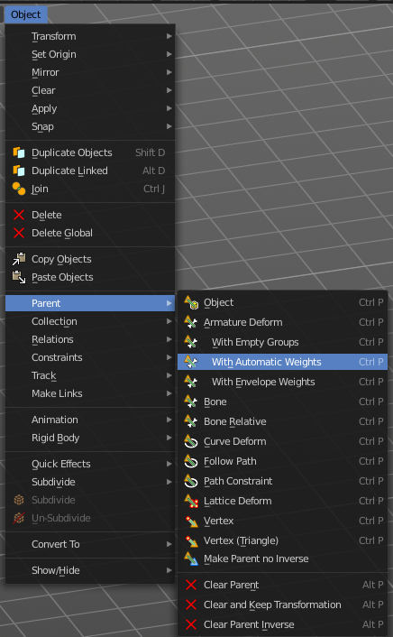
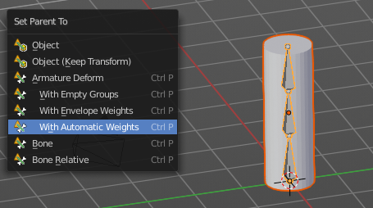

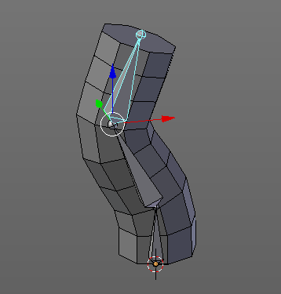

When everything went well then the mesh, in our case the Cylinder, is now part of the hierarchy of the armature.
And when you select the armature, and switch to Pose mode now, then you can already deform the mesh by posing the armature.

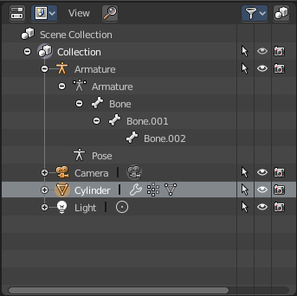
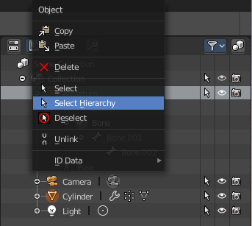
Note that currently the outliner does not indicate the hierarchy anymore. In former versions the cylinder became part of the armature when you parented it together. In the current version the cylinder remains where it is.
You can however select the whole hierarchy in the right click menu. And put it into an own collection for example.

Enter and leave Weight painting
Weight painting should happen in Pose mode so that you can pose your mesh to see the resulting deforming.
With the armature in Pose mode, select the mesh by clicking at it. Then enter Weight Paint mode. You can now do weight painting at the mesh.
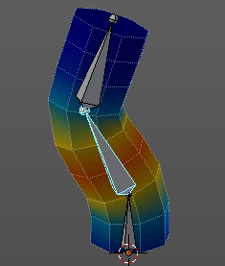
To leave Weight painting, simply switch back to Object mode. Or select the armature in the outliner.

Switch bones
The weighting that gets displayed when you enter Weight Paint mode is from the last active bone. So that's one method to define the bone that you want to weight paint. But you can also switch bones while in weight painting.
Hold down Ctrl, and left click at the bone that you want to set active. Then the weighting for this bone gets displayed.
Note that this just works when you come from Pose Mode. When you come from object mode, then you can't select another bone that way.

Weight painting a plain mesh
You can also do weight painting without an armature. Just at the pure mesh. In this case you just create the vertex groups for the mesh. And those vertex groups can be accessed in edit mode then for further usage. As shown in the shots below.
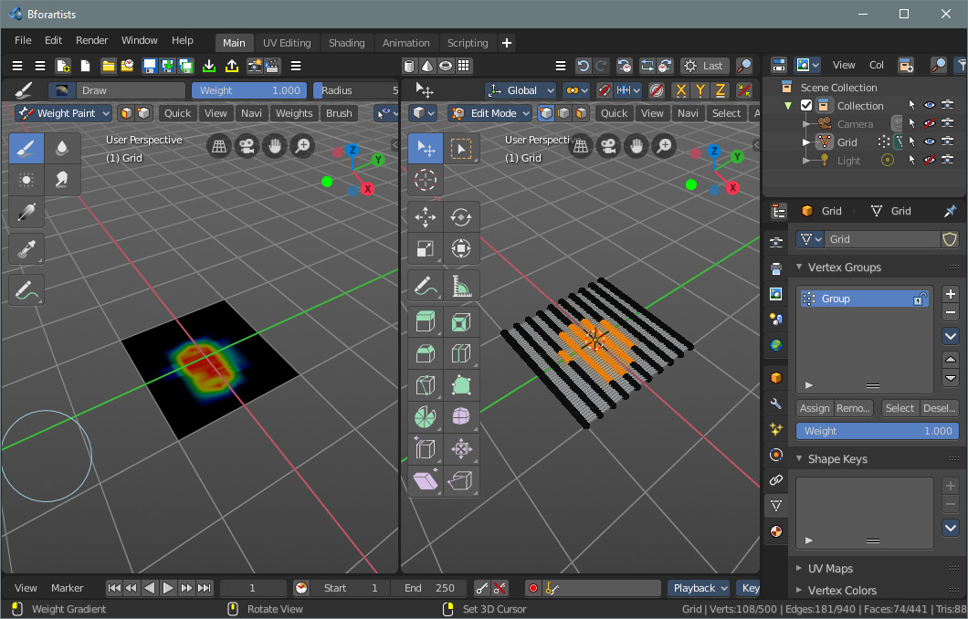

Weight painting in combination with particles
You can also combine weight painting with particles. To influence the density of hair for example. The weightmap can be assigned in the Vertex Groups panel in the Particles tab.
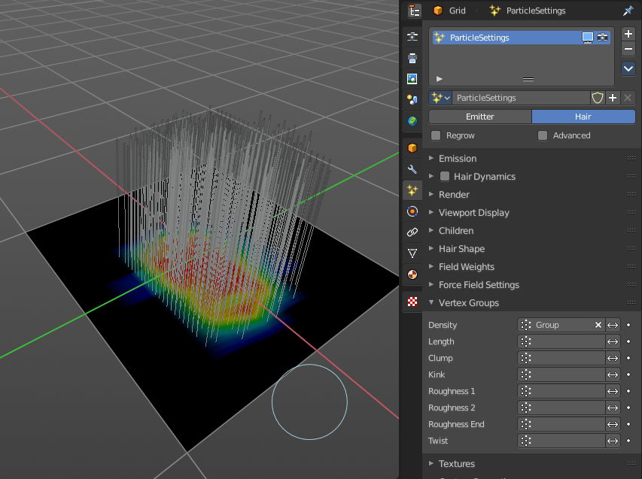

Brushes Panel
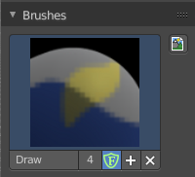
The Brush Panel contains the different Brushes and some Brush settings. Choose and adjust your current active brush.

Browse Brush
The big image at the top is a drop down box to choose a brush. Click at it, and you will see the different brushes. A click at one of the images will choose this brush then.
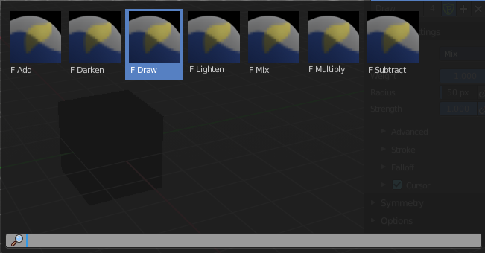
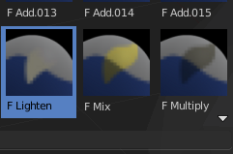
When you have added a few more brushes then the drop down box may be more than full. You will see some little white arrows then. Either in the top left or in the bottom right corner. They indicate that some brushes are hidden before or after the current display.
To scroll to this hidden content use the mouse wheel, or the arrow up and down buttons at the keyboard.

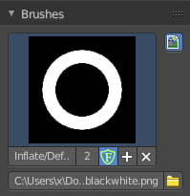
Custom Icon
The button at the right allows you to load a custom icon for your brush. It reveals a file browser below the image browser.

The edit box below the Image shows you the name of the current active brush.
The number right of it, in this case 2, indicates how much number of users ( internally ) this brush uses. This means that this data block (the brush) shares currently settings with at least one other object. Most probably the parent brush where we have created it from. Click at the value to make this brush a single user. The button will vanish then.
F set the brush to have a fake user. Zero user data-blocks are normally not saved. But sometimes you want to force the data to be kept even when the data block has no user.
The + button allows you to add a new pencil with the current settings. Note that the brushes are NOT saved when you close Bforartists. You can save them into the current blend file. Or you can save the startup file. But be careful here. This saves everything else of the current state of Bforartists too.
The X button deletes the brush as the active one. It does NOT delete it from the brushes list.

Brush Settings Panel

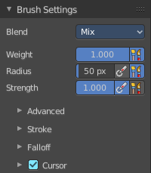
The Brush Settings Panel contains the Brush settings. The content differs, dependent of which brush you have chosen.

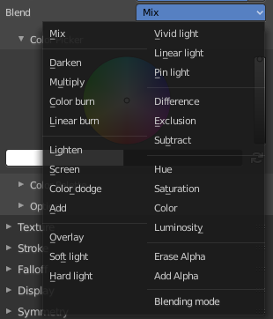
Blend
Define how the stroke will blend. You can choose between various blend modes.

Weight
Adjust the strength of the weight painting.

Size Pressure
The first button behind the edit box enables tablet pressure sensitivity for radius.

Radius
The Radius edit box allows you to adjust the radius of the brush. The button behind the edit box enables tablet pressure sensitivity for radius.

Size Pressure
The first button behind the edit box enables tablet pressure sensitivity for radius.

Use Unified Radius
The second button behind the edit box enables global radius size. Any modification at the radius will also modify the radius value for other paint tools.

Strength
The Strength edit box allows you to adjust the strength of the brush. The button behind the edit box enables tablet pressure sensitivity for strength.

Size Pressure
The first button behind the edit box enables tablet pressure sensitivity for radius.

Use Unified Radius
The second button behind the edit box enables global radius size. Any modification at the radius will also modify the radius value for other paint tools.

Brush Settings Panel - Advanced Sub panel

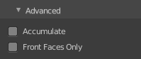
Accumulate
Accumulate stroke daubs on top of each other.

Front Faces Only
The Brush only paints at faces that faces to the view.

Brush Settings Panel - Stroke Sub panel

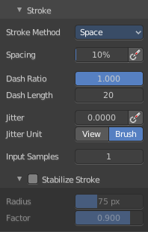
The Stroke panel contains settings to influence the behavior of the brush stroke. There are various stroke methods available. We will go through them one by one.

Stroke Panel with Stroke method Space
This is the default Stroke method. The sculpt stroke gets added continuously with given settings.
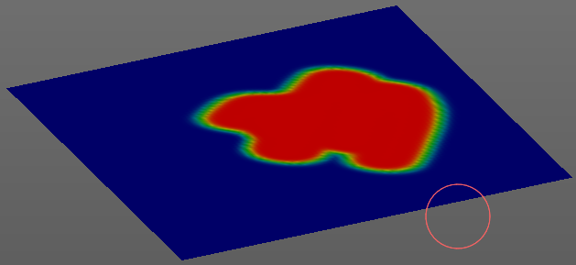

Spacing Edit Box
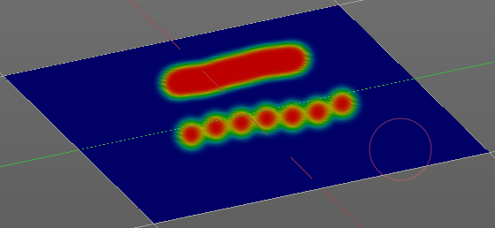
The drawing happens by mapping the pencil onto the mouse position. And when you move the mouse then the next mapping happens. Adjust the spacing after what mouse movement the next mapping should happen. The lower the value, the lower the distance between the single dots.

Spacing Pressure
The icon behind the edit box enables tablet pressure sensitivity for tablets.

Dash Ratio
Ratio of samples in a cycle that the brush is enabled.

Dash Length
Length of a dash cycle measured in stroke samples.

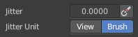
Jitter Edit Box
Add Jitter to the brush while painting.

Jitter Pressure
The icon behind the edit box enables tablet pressure sensitivity for tablets.

Jitter Unit
If the jitter happens in screen space in pixels, or relative to the brush size.

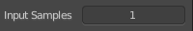
Input Samples Edit Box
Average multiple input samples together to smooth the brush stroke.

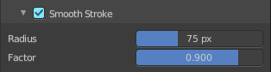
Stabilize Stroke
The brush lags behind the mouse position, and produces a much smoother stroke by that.

Smooth Stroke Radius Edit Box
Is just active when Smooth Stroke is activated. Adjust the radius of the smoothing.

Smooth Stroke Factor Edit Box
Is just active when Smooth Stroke is activated. Adjust the factor of the smoothing.

Stroke Panel with Stroke method Curve
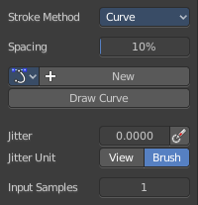
The Stroke method curve doesn't simply influence the way how the stroke is painted. It is a special method. First you draw a curve object by holding down ctrl and clicking with left mouse button. Then you tweak the curve. You can click at the curve point, and drag out handlers to make the curve points smooth.
Then you hit the Draw Curve button. And the curve gets drawn onto the surface.
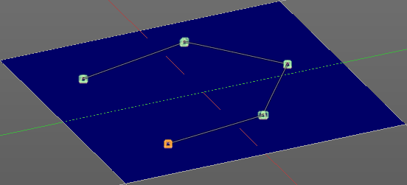
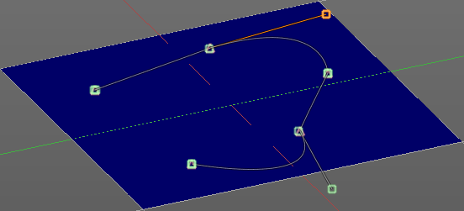
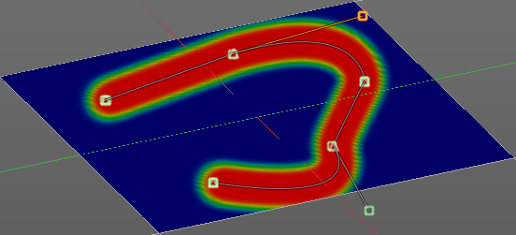

Spacing Edit Box
The drawing happens by mapping the pencil onto the mouse position. And when you move the mouse then the next mapping happens. Adjust the spacing after what mouse movement the next mapping should happen. The lower the value, the lower the distance between the single dots.
The icon behind the edit box enables tablet pressure sensitivity for tablets.

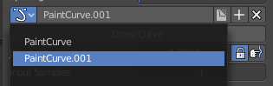
Paint Curve edit box
Here you set the active curve.
The first element is a drop down box where you will find your curves objects. You can have more than one.
The second element is the edit box that displays the active curve.
The number right of it, in this case 2, indicates how much number of users ( internally ) this brush uses. This means that this data block (the brush) shares currently settings with at least one other object. Most probably the parent brush where we have created it from. Click at the value to make this brush a single user. The button will vanish then.
F set the brush to have a fake user. Zero user data-blocks are normally not saved. But sometimes you want to force the data to be kept even when the data block has no user.
The + button allows you to add a new pencil with the current settings. Note that the brushes are NOT saved when you close Bforartists. You can save them into the current blend file. Or you can save the startup file. But be careful here. This saves everything else of the current state of Bforartists too.
The X button deletes the brush as the active one. It does NOT delete it from the brushes list.

Draw Curve Button
A click at it to turns the curve into a sculpt stroke.

Jitter Edit Box
Add Jitter to the brush while painting.

Jitter Pressure
The icon behind the edit box enables tablet pressure sensitivity for tablets.

Jitter Unit
If the jitter happens in screen space in pixels, or relative to the brush size.

Input Samples Edit Box
Average multiple input samples together to smooth the brush stroke.

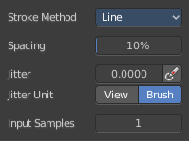
Stroke Panel with Stroke method Line
With Stroke method line you draw a line between a starting point and an endpoint. And when you release the mouse then the line gets sculpted.

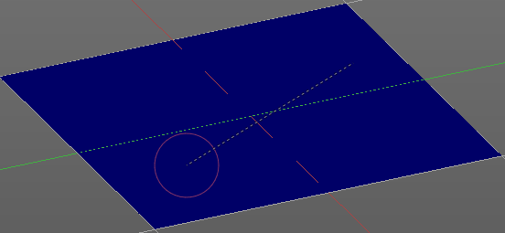
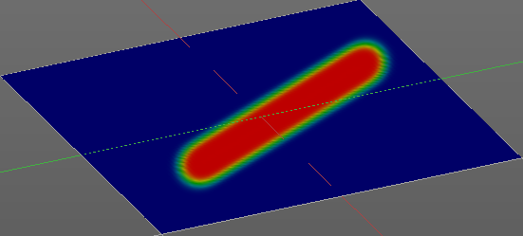

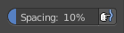
Spacing Edit Box
The sculpt drawing happens by mapping the pencil onto the mouse position. And when you move the mouse then the next mapping happens. Adjust the spacing after what mouse movement the next mapping should happen. The lower the value, the lower the distance between the single dots.
The icon behind the edit box enables tablet pressure sensitivity for tablets.

Jitter Edit Box
Add Jitter to the brush while painting.

Jitter Pressure
The icon behind the edit box enables tablet pressure sensitivity for tablets.

Jitter Unit
If the jitter happens in screen space in pixels, or relative to the brush size.

Input Samples Edit Box
Average multiple input samples together to smooth the brush stroke.

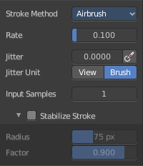
Stroke Panel with Stroke method Airbrush
The stroke acts like an airbrush pencil. The dots gets sprayed randomly.
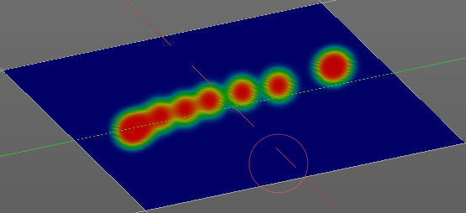

Rate Edit Box
Define the rate of the drawing.

Jitter Edit Box
Add Jitter to the brush while painting.

Jitter Pressure
The icon behind the edit box enables tablet pressure sensitivity for tablets.

Jitter Unit
If the jitter happens in screen space in pixels, or relative to the brush size.

Input Samples Edit Box
Average multiple input samples together to smooth the brush stroke.

Smooth Stroke
The brush lags behind the mouse position, and produces a much smoother stroke by that.

Smooth Stroke Radius Edit Box
Is just active when Smooth Stroke is activated. Adjust the radius of the smoothing.

Smooth Stroke Factor Edit Box
Is just active when Smooth Stroke is activated. Adjust the factor of the smoothing.

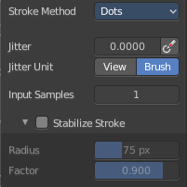
Stroke Panel with Stroke method Dots
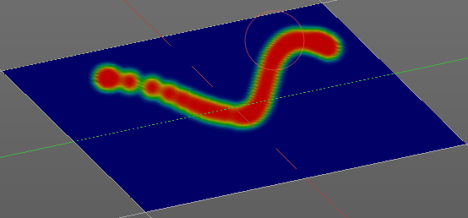
The stroke method Dots draws dots of the pencil onto the surface. The mapping happens from the current view. Means you will get distortions when your view is not aligned with the surface of the object.

Jitter Edit Box
Add Jitter to the brush while painting.

Jitter Pressure
The icon behind the edit box enables tablet pressure sensitivity for tablets.

Jitter Unit
If the jitter happens in screen space in pixels, or relative to the brush size.

Input Samples Edit Box
Average multiple input samples together to smooth the brush stroke.

Stabilize Stroke
The brush lags behind the mouse position, and produces a much smoother stroke by that.

Smooth Stroke Radius Edit Box
Is just active when Smooth Stroke is activated. Adjust the radius of the smoothing.

Smooth Stroke Factor Edit Box
Is just active when Smooth Stroke is activated. Adjust the factor of the smoothing.

Brush Settings Panel - Falloff Sub panel
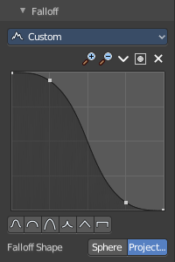
The Falloff panel allows you to define different falloffs methods for the border of the brush.


Selecting Points
You can select curve points. This reveals two edit boxes for the x and y coordinate of this point.
Selected points can be moved around. Left click at them, hold the mouse button down and move them to a new location.


Adding Points
You can add new curve points by simply left clicking at the curve. Move the mouse to position them where you need it.

Navigation elements
The navigation elements at the top are described from left to right.

Zoom in and out
The two buttons with the magnifying glass at it zooms in and out in the curve window.

Tools
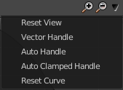
Tools is a menu where you can find some curve related tools.

Reset View
Resets the curve windows zoom.

Vector Handle
Set handle type to Vector.

Auto Handle
Set handle type to Auto.

Auto Clamped Handle
Set handle type to Auto Clamped.

Reset Curve
Resets the curve to the initial shape.


Use Clipping
Clipping options. Set up clipping for the stroke. The blue button at the top turns clipping on or off.

Delete Points
Deletes the selected curve point.


Curve Presets
Predefined curve presets.

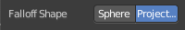
Falloff Shape
Use projected or spherical falloff.

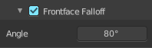
Front face Falloff
Blend brush influence by how much they face the front.

Angle
Paint most on faces pointing towards the view according to this angle.

Brush Settings Panel - Cursor Sub panel

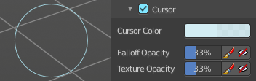
Adjust the color and appearance of the brush cursor to custom values.

Cursor Checkbox
Activate the custom settings.

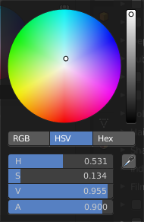
Cursor Color
Choose another color for the brush cursor. Double clicking at the color field will open a color picker.

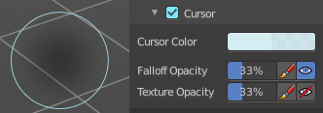
Falloff Opacity
You can turn on the cursor overlay with the eye button at the end. The falloff opacity slider allows you to adjust the opacity of this cursor overlay.

Override Overlay
Hide the Cursor Overlay when painting.

Use Cursor Overlay
Turn on Cursor Overlay.

Texture Opacity
This is for the case when you paint with a texture brush. You can turn on the Texture overlay with the eye button at the end. The falloff opacity slider allows you to adjust the opacity of this cursor overlay.

Override Overlay
Hide the Texture Overlay when painting.

Use Cursor Overlay
Turn on Texture Overlay.

Symmetry Panel
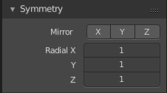

Mirror
Mirror along given axis.
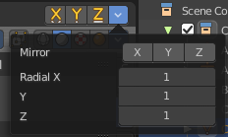
The same buttons plus the whole Symmetry Lock Panel as a drop down menu can also be found in the tool settings bar as icon buttons. This allows quicker access and better

Radial
Tiling. The number of times to repeat the strokes across the surface.

Options Panel

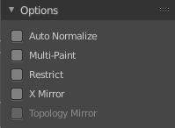
Auto Normalize
Ensure that all bone deforming vertex groups adds up to 1.0 while weight painting.

Multi Paint
Paint across the weights of all selected bones, maintaining their relative influence.

Restrict
Restrict painting to vertices in the group.

X Mirror
X Axis Mirror Editing.

Topology Mirror
Needs X Mirror ticked. Use topology based mirroring. For when both sides of the mesh have matching, unique topology.

